**Plotting the best fitting line and Plotting points along the least square line**

ggplot()+

geom_point(data=dat, aes(x=x, y=y))

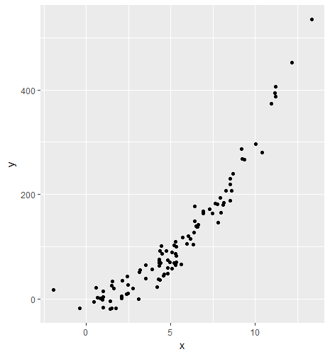

We will find the best fitting line using lm function

> lm(y~x, data=dat)

Call:

lm(formula = y ~ x, data = dat)

Coefficients:

(Intercept) x

-65.27 34.04

x1 <- function(x){

34.04*x-65.27

}

ggplot()+

geom_point(data=dat, aes(x=x, y=y))+

stat_function(data=data.frame(x=c(-5, 15)), aes(x=x), fun=x1)

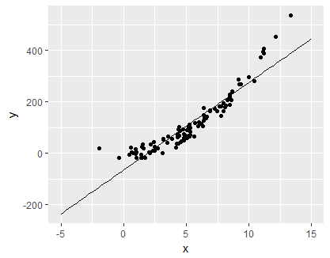

**Plotting the points along least squared line**

f <- function(x){

34.04*x-65.27

}

ggplot()+

geom_point(data=dat, aes(x=x, y=y))+

stat_function(data=data.frame(x=c(-5, 15)), aes(x=x), fun=f)

|  |
| --- |
| > x <- dat$x  > y <- f(x)  > means <- data.frame(x,y) |
|  |
| |  | | --- | | > | |

ggplot()+

geom_point(data=dat, aes(x=x, y=y))+

stat_function(data=data.frame(x=c(-5, 15)), aes(x=x), fun=f)+

geom_point(data=means, aes(x=x, y=y), color='red', size=3)

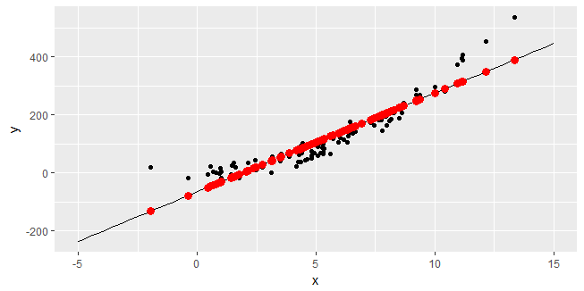

Now if you take a look at block point it will straight drop a red point on the line that corresponds to that data point.